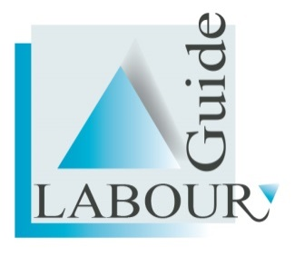

Order Form

The S.A. Labour Guide Labour Law and Employment Manual 2016

(Available on a USB Flash Drive and online)

Kindly fax the completed form to (012) 661 1411 or email info@labourguide.co.za

Full Company Name: ____________________________________________________________

Full Postal Address ____________________________________________________________

____________________________________________________________

Full Delivery address: ____________________________________________________________

____________________________________________________________

VAT registration number (If applicable): _______________________________________________

USB Flash Drives @ R 2490-00 per drive/ online license (incl. VAT)

Number of USB Flash Drives __________

Your contact telephone number, including dial code: ________________________

Your fax number including dial code: ___________________________________

Your e-mail address: ________________________________

Name of Contact person: ____________________________
Top of Form

Bottom of Form
Please do not deposit any fees without an order reference number or make any payments until you receive an official invoice.

Upon receipt of your properly completed order form, we will send you a Tax Invoice by e-mail or Fax.

Fax or e-mail a copy of the bank deposit slip to fax number (012) 661 1411

USB Flash Drives will be couriered to you.

Please allow 5 working days for delivery.

Phone Peraldo/ Hanlie at (012) 661 3208 or Deidre at (012) 666 8284

